Solutions of Homework 4

5.1 Logic type.

No | Component | Logic Type
A | Multiplexer | Combinational
B | Comparator | Combinational
C | Incrementer/decrementer | Combinational
D | Barrel Shifter | Combinational
E | Multiplier | Mixed
F | Register | Sequential
G | Memory | Sequential
H | ALU | Combinational
I | Carry look-ahead adder | Combinational
J | Latch | Sequential
K | FSM | Mixed

5.2 Stuck-at-0 Fault

a. RegWrite = 0: All R-format instructions, in addition to lw, will not work because these instructions will not be able to write their results to the register file.
b. ALUop1 = 0: All R-format instructions except addition will not work correctly because the ALU will perform addition instead of the required ALU operation.
c. ALUop0 = 0: beq instruction will not work because the ALU will perform addition instead of subtraction, so the branch outcome may be wrong.
d. Branch (or PCSrc) = 0: beq will not execute correctly. The branch instruction will always be not taken even when it should be taken.
e. MemRead = 0: lw will not execute correctly because it will not be able to read data from memory.
f. MemWrite = 0: sw will not work correctly because it will not be able to write to the data memory.

5.3 Stuck-at-1 Fault

a. RegWrite = 1: sw and beq should not write results to the register file. sw (beq) will overwrite a random register with either the store address (branch target) or random data from the memory data read port.
b. ALUop0 = 1: lw and sw will not work correctly because they will perform subtraction instead of the addition necessary for address calculation.
c. ALUop1 = 1: lw and sw will not work correctly. lw and sw will perform a random operation depending on the least significant bits of the address field instead of addition operation necessary for address calculation.
d. Branch = 1: Instructions other than branches (beq) will not work correctly if the ALU Zero signal is raised. An R-format instruction that produces zero output will branch to a random address determined by its least significant 16 bits.
e. MemRead = 1: All instructions will work correctly. (Data memory is always read, but memory data is never written to the register file except in the case of lw.)
f. MemWrite = 1: Only sw will work correctly. The rest of instructions will store their results in the data memory, while they should not.

5.8 We wish to add the instruction jr (jump register) to the single-cycle datapath. Add any necessary datapaths and control signals to the single-cycle datapath of Figure 5.17 on page 307 and show the necessary additions to Figure 5.18 on page 308. You can photocopy these figures to make it faster to show the additions.

A modification to the datapath is necessary to allow the new PC to come from a register (Read data 1 port), and a new signal (e.g., JumpReg) to control it through a multiplexer as shown figure below.
A new line should be added to the truth table in Figure 5.18 on page 308 to implement the jr instruction and a new column to produce the JumpReg signal.
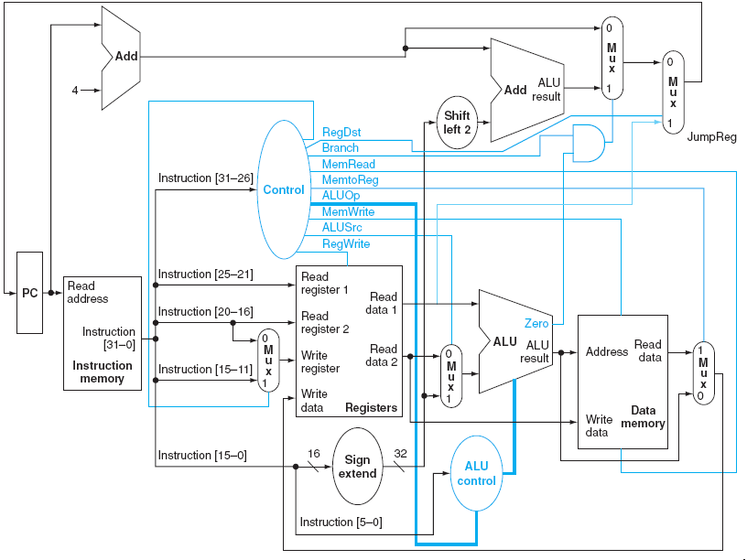

5.9 This question is similar to Exercise 5.8 except that we wish to add the instruction sll (shift left logical).

A modification to the data path is necessary (see the figure below) to feed the shamt field (instruction[10:6]) to the ALU in order to determine the shift amount. The instruction is in R-Format and is controlled according to the first line in Figure 5.18 on page 308.
The ALU will identify the sll operation by the ALUop field.
Figure 5.13 on page 302 should be modified to recognize the opcode of sll: the third line should be changed to 1X1X0000 0010 (to discriminate the add and sll functions), and a new line, inserted, for example, 1X0X0000 0011 (to define sll by the 0011 operation code).
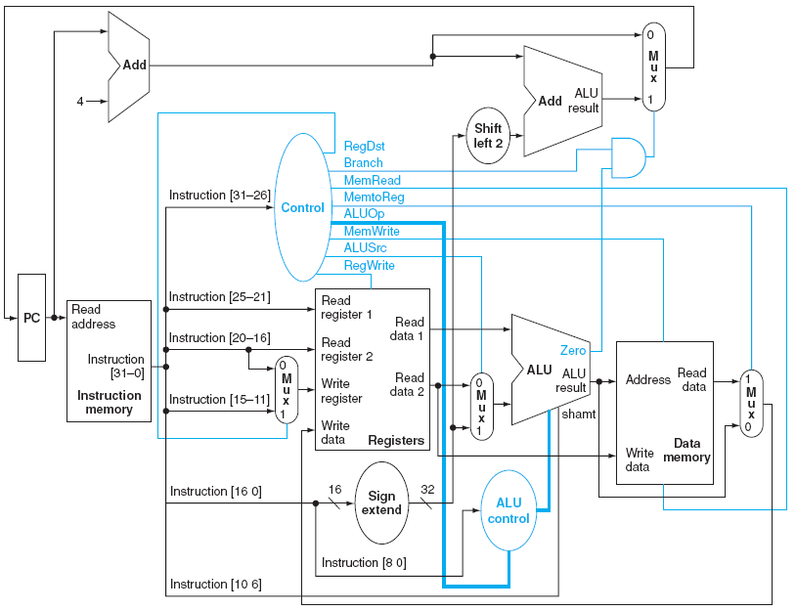

5.10 This question is similar to Exercise 5.8 except that we wish to add the instruction lui (load upper immediate).

Here one possible lui implementation is presented:
This implementation doesn’t need a modification to the datapath. We can use the ALU to implement the shift operation. The shift operation can be like the one presented for Exercise 5.9, but will make the shift amount as a constant 16. A new line should be added to the truth table in Figure 5.18 on page 308 to define the new shift function to the function unit. (Remember two things: first, there is no funct field in this command; second, the shift operation is done to the immediate field, not the register input.)
RegDst = 1: To write the ALU output back to the destination register ($rt).
ALUSrc = 1: Load the immediate field into the ALU.
MemtoReg = 0: Data source is the ALU.
RegWrite = 1: Write results back.
MemRead = 0: No memory read required.
MemWrite = 0: No memory write required.
Branch = 0: Not a branch.
ALUOp = 11: sll operation.
This ALUOp (11) can be translated by the ALU as shl, ALUI 1 ,16 by modifying the truth table in Figure 5.13 in a way similar to Exercise 5.9.

5.29 Stuck-at-0 with multiple-cycle datapath:

a. RegWrite = 0: All R-format instructions, in addition to lw, will not work because these instructions will not be able to write their results to the register file.
b. MemRead = 0: None of the instructions will run correctly because instructions will not be fetched from memory.
c. MemWrite = 0: sw will not work correctly because it will not be able to write to the data memory.
d. lRWrite = 0: None of the instructions will run correctly because instructions fetched from memory are not properly stored in the IR register.
e. PCWrite = 0: Jump instructions will not work correctly because their target address will not be stored in the PC.
f. PcWritecond = 0: Taken branches will not execute correctly because their target address will not be written into the PC.

5.30 Stuck-at-1 faults with multi-cycle datapath:

a. RegWrite = 1: Jump and branch will write their target address into the register file. sw will write the destination address or a random value into the register file.
b. MernRead = 1: All instructions will work correctly. Memory will be read all the time, but IRWrite and lorD will safeguard this signal.
c. MemWrite = 1: All instructions will not work correctly. Both instruction and data memories will be written over by the contents of register B.
d. IRWrite = 1: lw will not work correctly because data memory output will be translated as instructions.
e. PCWrite = 1: All instructions except jump will not work correctly. This signal should be raised only at the time the new PC address is ready (PC + 4 at cycle 1 and jump target in cycle 3). Raising this signal all the time will corrupt the PC by either ALU results of R-format, memory address of lw/sw, or target address of conditional branch, even when they should not be taken.
f. PCWriteCond = 1: Instructions other than branches (beq) will not work correctly if they raise the ALU’s Zero signal. An R-format instruction that produces zero output will branch to a random address determined by their least significant 16 bits.

5.31 This exercise is similar to Exercise 5.13 but more general. Determine whether any of the control signals in the single-cycle implementation can be eliminated and replaced by another existing control signal, or its inverse. Note that such redundancy is there because we have a very small set of instructions at this point, and it will disappear (or be harder to find when we implement a larger number of instructions).

RegDst can be replaced by /ALUSrc, /MemtoReg, /MemRead, ALUOp1.
MemtoReg can be replaced by /RegDst, ALUSrc, MemRead, or /ALUOp1.
Branch and ALUOp0 can replace each other.

5.32 We wish to add the instruction lui (load upper immediate) to the multi-cycle datapath described in this chapter. Use the same structure of the multi-cycle datapath of Figure 5.28 on page 323 and show the necessary modifications to the finite state machine of Figure 5.38 on page 339. You may find it helpful to examine the execution steps shown on pages 325 through 329 and consider the steps that will need to be performed to execute the new instruction. How many cycles are required to implement this instruction?

We use the same datapath, so the immediate field shift will be done inside the ALU.
- Instruction fetch step: This is the same (IR <= Memory [PC]; PC <= PC + 4)
- Instruction decode step: We don’t really need to read any register in this stage if we know that the instruction in hand is a lui, but we will not know this before the end of this cycle. It is tempting to read the immediate field into the ALU to start shifting next cycle, but we don’t yet know what the instruction is. So we have to perform the same way as the standard machine does.
A <= $rs; B <= $rt; ALUOut <= PC + (sign-extend( immediate field));
- Execution: Only now we know that we have a lui . We have to use the ALU to shift left the low-order 16 bits of input 2 of the multiplexer. (The sign extension is useless, and sign bits will be flushed out during the shift process.)
ALUOut <= {IR[15-0],16(0)}
- Instruction completion: Reg[IR[20-16]] = ALUOut. The first two cycles are identical to the FSM of Figure 5.38. By the end of the second cycle the FSM will recognize the opcode. We add the Op=’lui’, a new transition condition from state 1 to a new state 10. In this state we perform the left shifting of the immediate field: ALUSrcA = x, ALUSrcB = 10, ALUOp = 11 (assume this means left shift of ALUSrcB). State 10 corresponds to cycle 3. Cycle 4 will be translated into a new state 11, in which RegDst = 0, RegWrite, MemtoReg = 0. State 11 will make the transition back to state 0 after completion.
As shown above the instruction execution takes 4 cycles.

5.36 Two important parameters control the performance of a processor: cycle time and cycles per instruction. There is an enduring trade-off between these two parameters in the design process of microprocessors. While some designers prefer to increase the processor frequency at the expense of large CPI, other designers follow a different school of thought in which reducing the CPI comes at the expense of lower processor frequency.
Consider the following machines, and compare their performance using the SPEC CPUint 2000 data from Figure 3.26 on page 228.
M1: The multi-cycle datapath of Chapter 5 with a 4 GHz clock.
M2: A machine like the multi-cycle datapath of Chapter 5, except that register updates are done in the same clock cycle as a memory read or ALU operation. Thus in Figure 5.38 on page 339, states 6 and 7 and states 3 and 4 are combined. This machine has an 3.2-GHz clock, since the register update increases the length of the critical path.
M3: A machine like M2 except that effective address calculations are done in the same clock cycle as a memory access. Thus states 2, 3, and 4 can be combined, as can 2 and 5, as well as 6 and 7. This machine has a 2.8-GHz clock because of the long cycle created by combining address calculation and memory access.
Find out which of the machines is fastest. Are there instruction mixes that would make another machine faster, and if so, what are they?

Effective CPI = Sum(operation frequency operation latency)
MIPS = Frequency/CPleffective
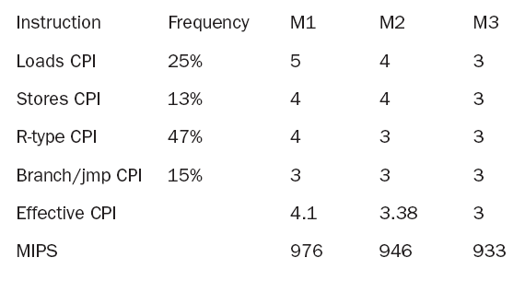
From the results above, the penalty imposed on frequency (for all instructions) exceeds the gains attained through the CPI reduction. M1 is the fastest machine.
The more the load instructions in the instruction mix, the more the CPI gain we can get for the M2 and M3 machines. In the extreme case we have all instructions loads, M1 MIPS = 800, M2 MIPS = 800, and M3 MIPS = 933.3, so M3 becomes the best machine in such a case.

